Email Validation:

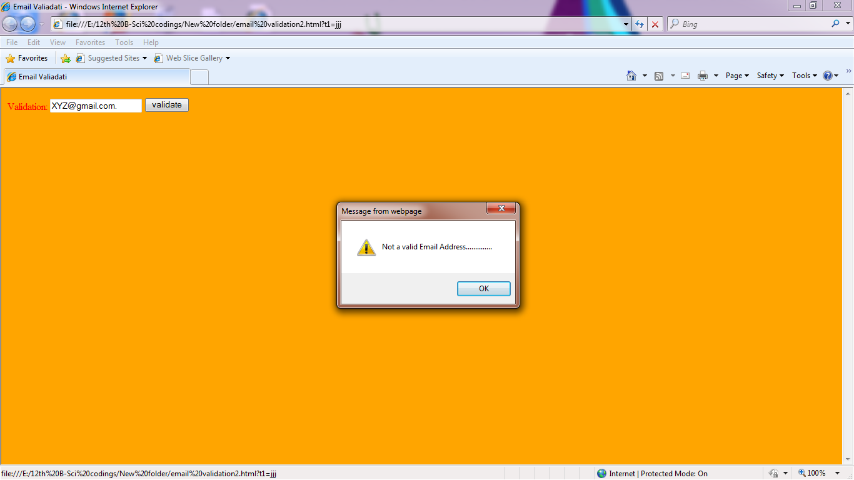

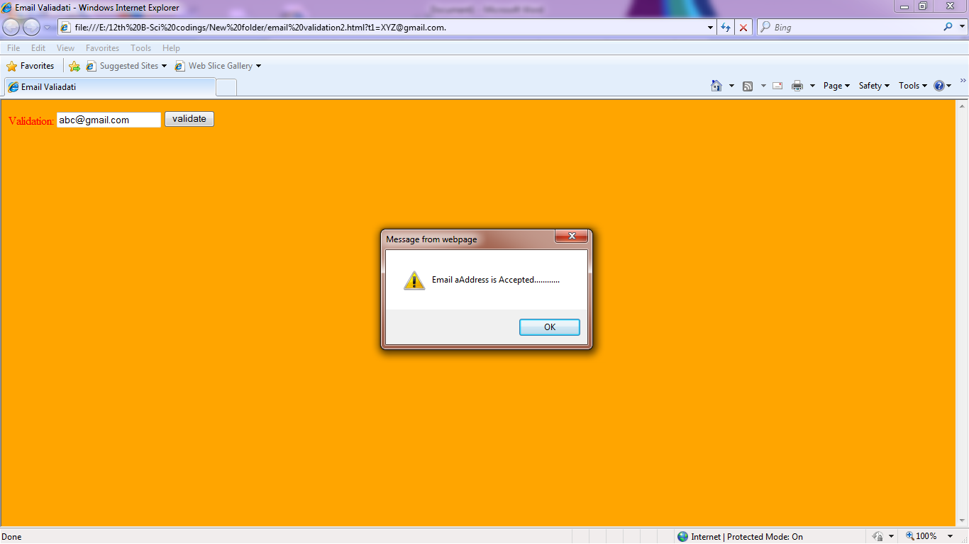

Email Validation Program:

<html><head><title>Email Valiadati</title><script language="Javascript">

function abc()

{

var x=f1.t1.value;

var startat=x.indexOf("@");

var lastat=x.lastIndexOf("@");

var startdot=x.indexOf(".");

var lastdot=x.lastIndexOf(".");

if(startat<1||lastdot<startat+2||lastdot+2>x.length)

{

alert("Not a valid Email Address..............");

f1.t1.focus();

}else

{ alert("Email aAddress is Accepted............")

}

}

</script>

</head>

<body bgcolor="orange" text="red">

<form name="f1" onsubmit=" abc()" >

Validation: <input type="text" name="t1">

<input type="submit" value="validate"></form></body></html>